Redireccionar Https en IIS6

- Abilitar SSL en el site

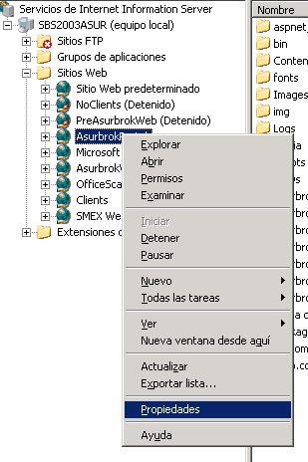 | 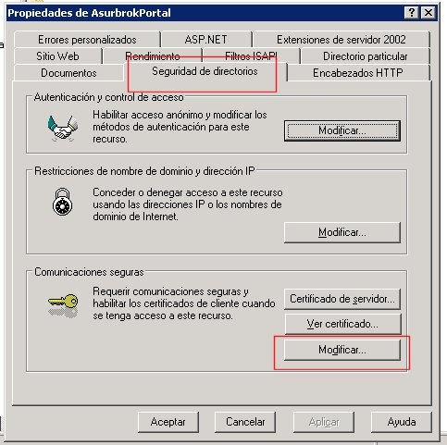
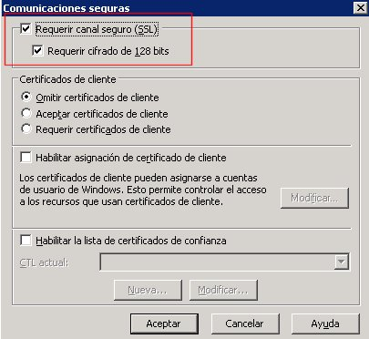

- Redireccionar el error 403.4 a una aarchivo html

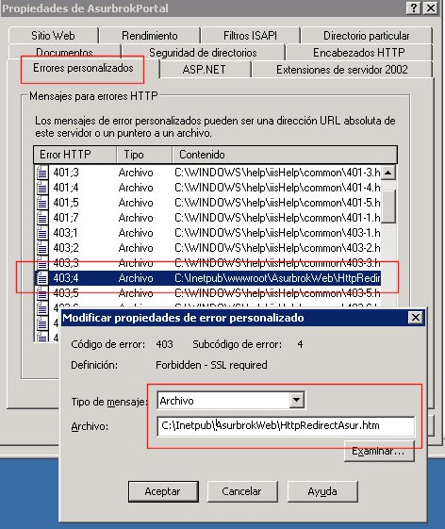

- Archivo para redireccionar de http a https

<!-- beginning of HttpRedirect.htm file -->
<script type="text/javascript">

function redirectToHttps()
{
var httpURL = window.location.hostname+window.location.pathname;
if(httpURL[httpURL.length-1] == "/"){
httpURL = httpURL.substring(0,httpURL.length-1);
}
var httpsURL = "https://" + httpURL + ":483/" ;
window.location = httpsURL ;
}
redirectToHttps();
</script>
<!-- end of HttpRedirect.htm file -->

